ASSIGNMENT NUMBER 4
STATEMENT:
Write a function template and class template selection sort. Write a program that inputs,
sorts and outputs an integer array and a float array.
AIM :
C++ Program to implement and understand the concepts of Class Template and Function
Template. Using these, sorting the array of integer and float elements by selection sort.
DESCRIPTION:
In this program, we have created a class template to declare two variables in private access
specifier and three functions in public access specifier. We have created a function template
and defined the three functions. Using the template facility, the user can input array
elements of integer or float type. The input elements will then be sorted using the selection
sort and displayed accordingly. To access the class template variables, there are two objects
created (one for integer, the other for float).
OOP CONCEPT USED:
• Template Class
• Template Function
• do while loop
• Menu driven statements
SOURCE CODE:
#include<iostream>
using namespace std;
template <class T>
void selectionSort(T arr[], int n)
{
int i, j, min_idx;
for (i = 0; i < n-1; i++)
{
min_idx = i;
for (j = i+1; j < n; j++)
if (arr[j] < arr[min_idx])
min_idx = j;
T temp=arr[min_idx];
arr[min_idx]=arr[i];
arr[i]=temp;

}
}

template <class P>
void printArray(P arr[], int size)
{
int i;
for (i=0; i < size; i++)
cout << arr[i] << " ";
cout << endl;
}

int main()
{ int k;
int n;
do{
cout<<"ENTER 1. TO SORT INTEGER ARRAY \n 2. TO SORT FLOAT ARRAY"<<endl;
cin>>n;
case 1:
cout<<"\n INTEGER ARRAY";
cout<<"\n ENTER SIZE OF ARRAY";
cin>>k;
int arr[k];
for(int i=0;i<k;i++)
{
cout<<"\n ENTER ELEMENT";
cin>>arr[i];
}
selectionSort(arr, k);
cout << "\nSORTED ARRAY: \n";
printArray(arr, k);
break;
case 2:

cout<<"\n FLOAT ARRAY";
cout<<"\n ENTER THE SIZE OF ARRAY";
cin>>k;
float carr[k];
for(int i=0;i<k;i++)
{
cout<<"\n ENTER ELEMENT NO:";
cin>>carr[i];
}
selectionSort(carr, k);
cout << "\nSORTED ARRAY: \n";
printArray(carr, k);
break;
default:"\n ENTER A VALID CHOICE"<<endl;
}while(n<3);
return 0;
}

OUTPUT:

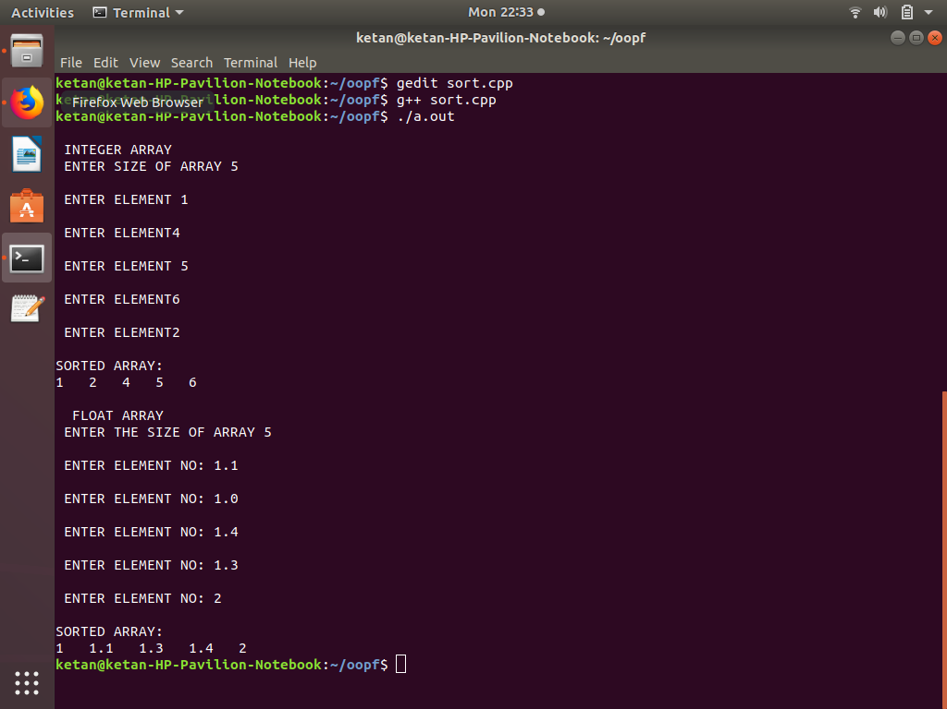

CONCLUSION:
Hence, we learnt the concept of class template and function template. We also learnt the
selection sort technique.

